12mm Platinum Range Double Upright Expandable Door.

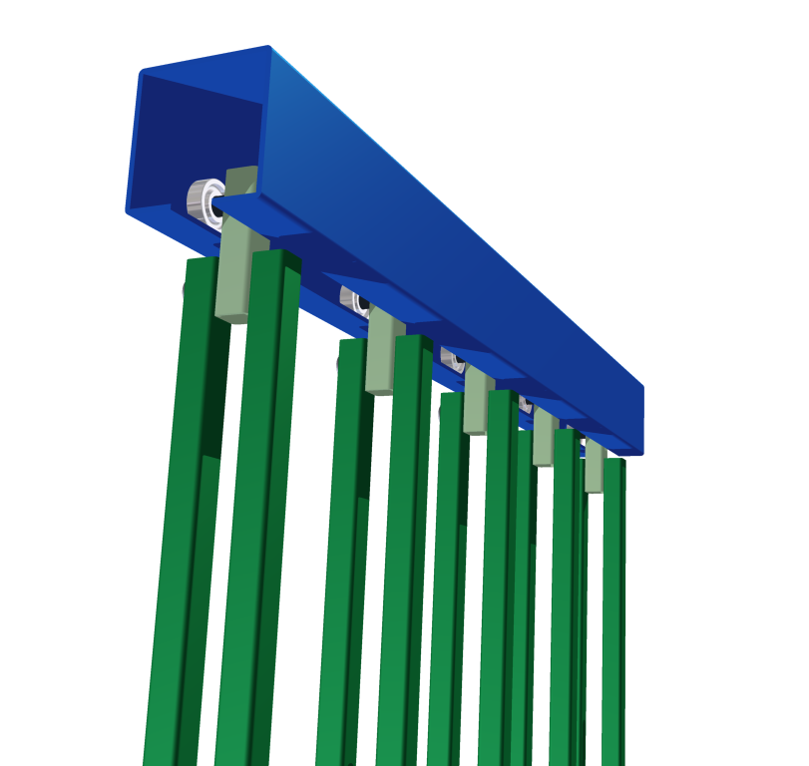
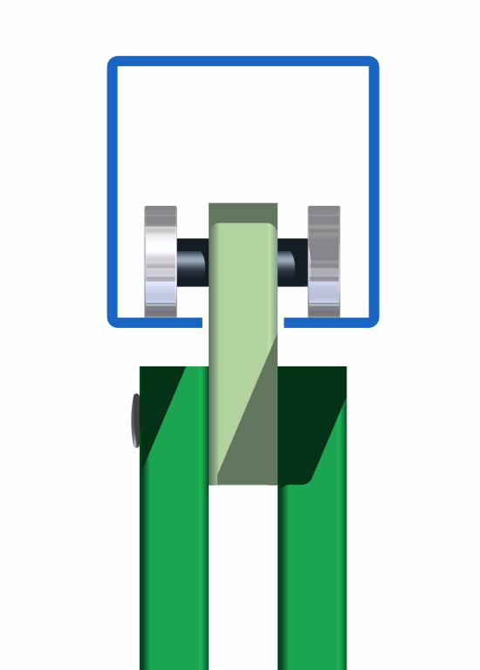
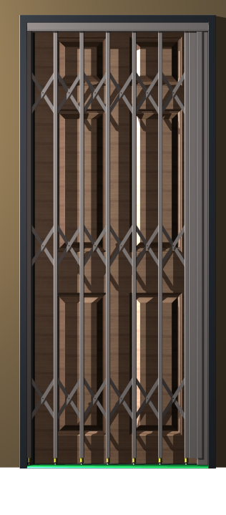

Top Track manufactured from galvanized material. Uprights supported with sealed Stainless Steel Bearings
12 mm Double Steel Uprights supported from Steel Top Track

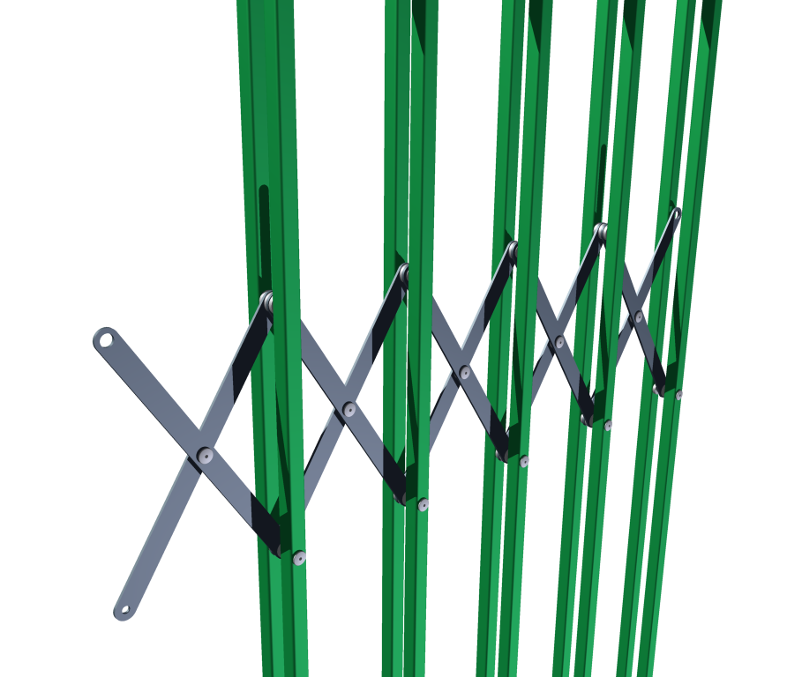

Double Upright Flight System Protected between Uprights

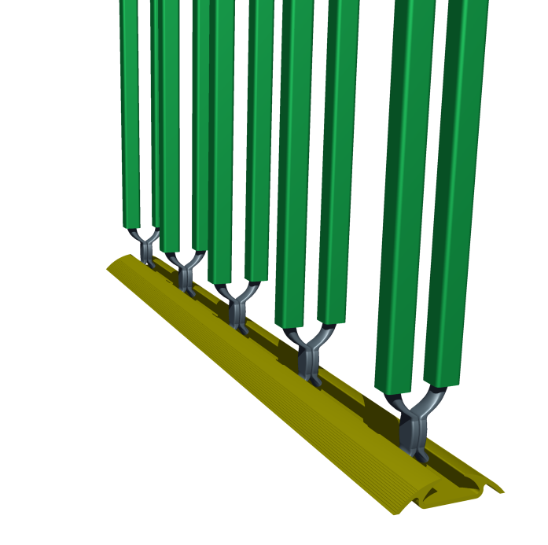
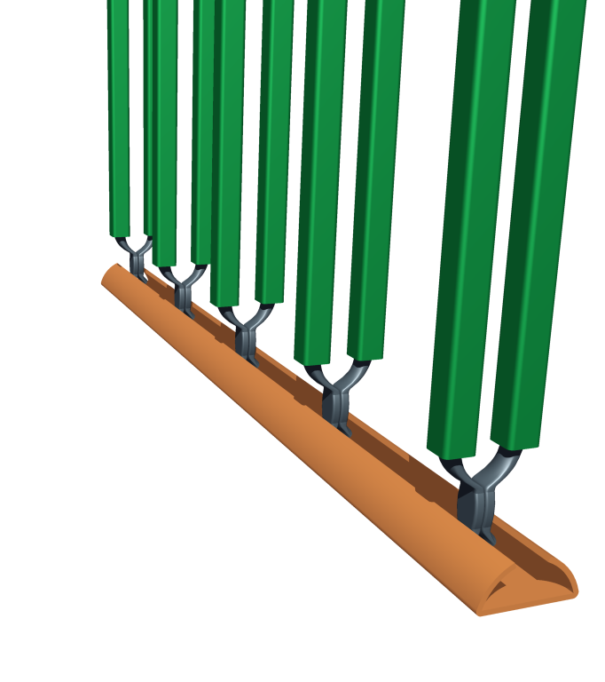




Galvanized Steel Bottom Feet

Optional Aluminium
Bottom Track
Standard Galvanized
Steel Bottom Track

